Changing the Translation method

Original:

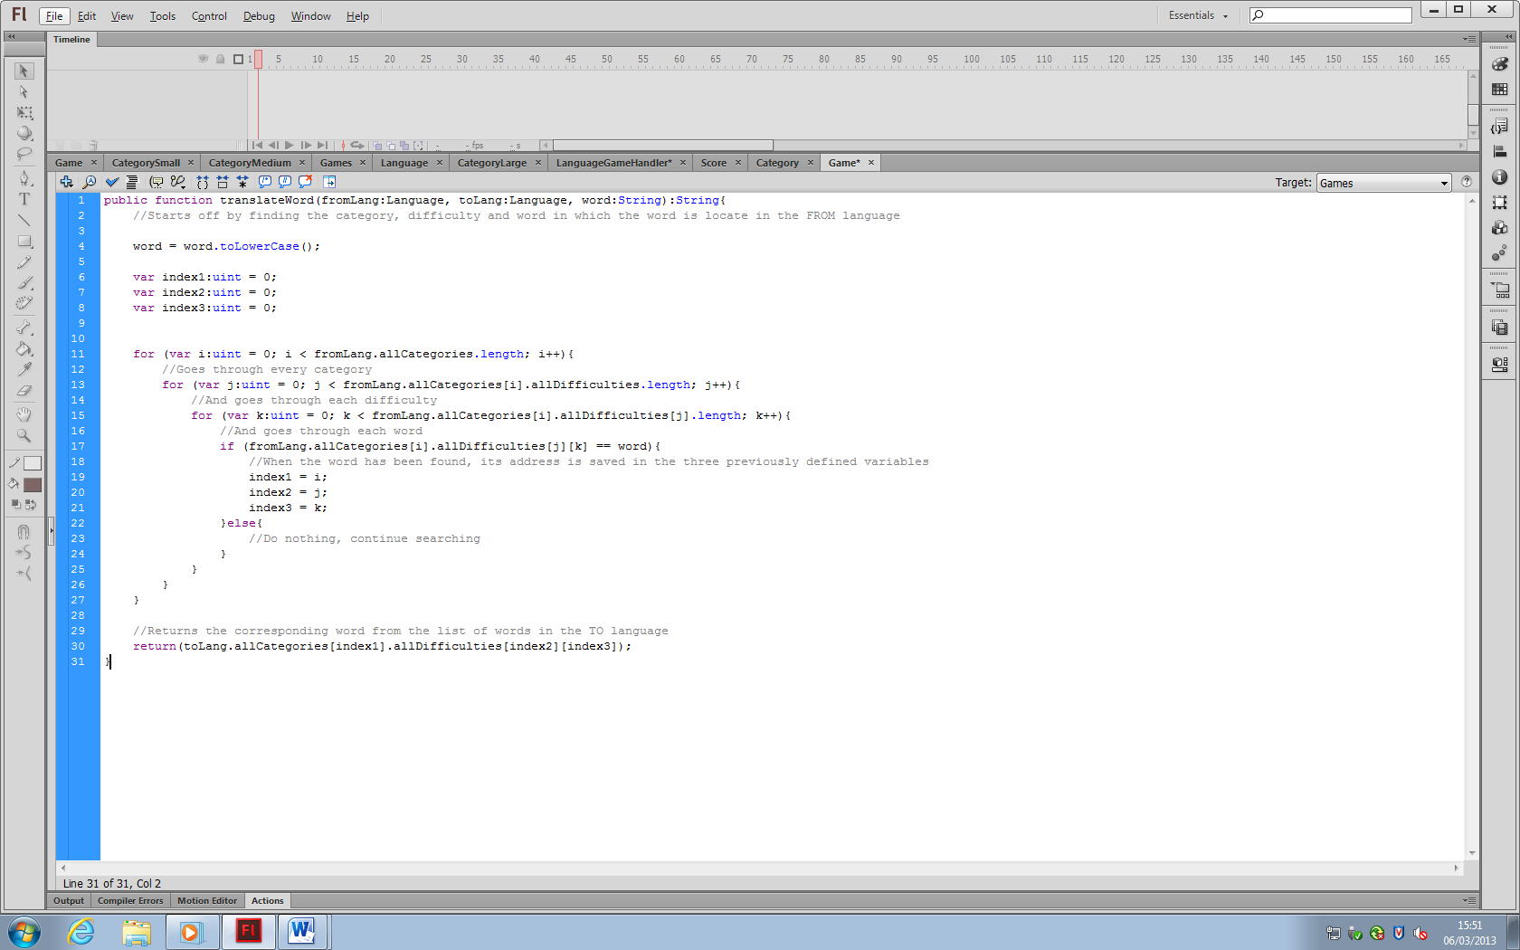

New:

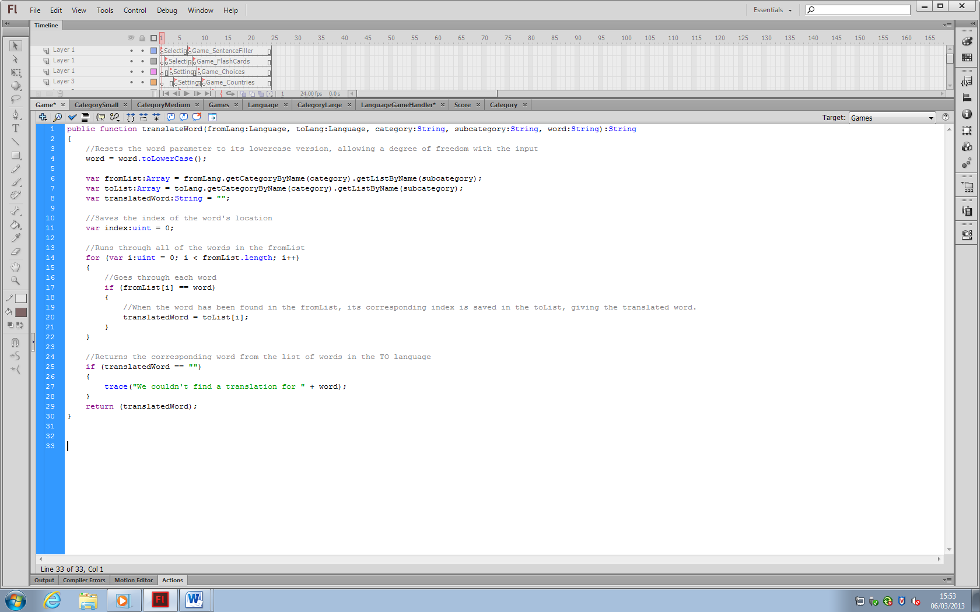

Changes:

The method now has more parameters: category and subcategory. Using this information, the method no longer searches for which category and subcategory the translated word is being held. As seen between lines 11 and 27 on the **original**, there was at first a searching algorithm. Now, it has been replaced with a much smaller one between lines 14 and 22 in the **new** code, making the method more efficient. Additionally, the method now tells the programmer whether or not a word has not been found, as this is not useful information for the user.